

****Year 10 General Chemistry****

****Reaction Rates and Producing Gases****

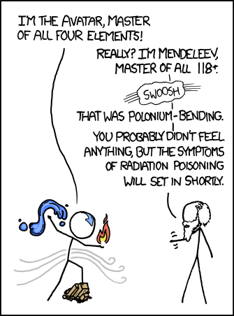



(Munroe, 2011)(Munroe, 2019)

**Name: ______________________**

**Rates of Chemical Reactions**

Reaction rate in chemistry is the **speed** at which a chemical reaction occurs. Some reactions occur so quickly that they are explosive e.g., a bomb, and some occur very slowly e.g., the rusting of steel.

The rate at which a reaction occurs depends upon the type of reactants and the conditions under which the reaction takes place. Changing the conditions can change the rate of the reaction. We will study five factors that can change the rate of a chemical reaction. In order to understand how these factors change the rate of a reaction we need to understand what occurs during a chemical reaction. The collision theory enables us to understand and explain changing reaction rates.

**Collision Theory**

For a chemical reaction to occur, the reactant particles must:

* collide with each other.
* collide with each other with a minimum amount of energy, called activation energy.
* collide with each other with the correct orientation.

If we can change the conditions to affect any one of the above, then we can change the rate of the reaction.

**Factors that affect the rate of a reaction**

There are five general factors that can affect the rate of a reaction:

1. Temperature
2. Concentration
3. Agitation
4. Surface area
5. Catalysts (or inhibitors). A catalyst speeds up a reaction, an inhibitor slows it down.

(Light of a particular wavelength may also speed up a reaction)

* 1. **Temperature** – changing the temperature changes the kinetic energy of the particles.

Increasing temperature increases the kinetic energy of the particles and decreasing temperature decreases the kinetic energy of the particles in the reaction.

Increasing temperature will increase **the proportion of collisions that have sufficient kinetic energy to meet the activation energy** which increases the rate of successful collisions and so increases the reaction rate.

Also, by increasing the kinetic energy of the particles, the particles move faster and so the rate of collisions increases which also increases the reaction rate.

The opposite occurs if you decrease the temperature of a reaction.

Decreasing temperature will **decrease** the proportion of collisions that have sufficient kinetic energy to meet the activation energy which **decreases** the **rate of successful collisions** and so **decreases** the reaction rate.

Also, by decreasing the kinetic energy of the particles, the particles move **slower** and so the **rate** **of collisions decreases** which also **decreases** the reaction rate.

* 1. **Concentration**

Increasing the concentration of one or more of the reactants decreases the distance between the particles which increases the rate of collisions which increases the reaction rate.

* 1. **Agitation (stirring)**

Agitation increases the number of reactant particles exposed to each other at the same time which increases the rate of collisions which increases the reaction rate.

* 1. **Surface area**

Increasing the surface area of one or more of the reactants exposes more reactant particles to each other at the same time which increases the rate of collisions which increases the reaction rate.

The surface area can be increased by grinding/ breaking up solid reactants into smaller pieces e.g., capsules contain powdered medicine.

* 1. **Catalysts**

These are substances which increase the rate of chemical reactions but are not consumed or chemically changed during the reaction.

Catalysts provide an alternate reaction pathway with a lower activation energy. This means a greater proportion of reactant particles will have sufficient kinetic energy to meet the activation energy which increases the rate of successful collisions which increases the reaction rate.

**Rates of reactions**

* 1. What are the three requirements that have to be met by the reactant particles in order for a chemical reaction to take place?

1. reactants must collide
2. reactants must collide with sufficient energy
3. reactants must collide with the correct orientation
   1. The rate of a reaction can be increased by five factors ***(list them below)***:

* Temperature
* Concentration
* Agitation
* Surface area
* Catalysts
  1. For each scenario below, state the factor that is being changed to alter the reaction rate.

1. Firewood is chopped into small pieces to make lighting a fire easier.

Greater surface area

1. A black powder called manganese dioxide causes hydrogen peroxide to decompose faster than normal. The powder is not used up during the reaction.

catalyst

1. Food left in the fridge lasts longer than food left out.

Decreases temperature

1. Coal dust can cause explosions.

Greater surface area

* 1. Use the collision theory to explain the following observations:

(a) A piece of magnesium metal burns faster in a jar of pure oxygen than in air.

Increasing the concentration of oxygen decreases the distance between the particles which increases the rate of collisions and increases the reaction rate.

(b) In 2 mol L-1 HCl, iron wool produces hydrogen gas faster than an iron

nail of the same mass.

Increasing the surface area of the iron exposes more reactant particles to each other at the same time which increases the rate of collisions and increases the reaction rate.

(c) Hydrogen peroxide takes longer to decompose when it is left in the fridge.

Decreasing temperature will decrease the proportion of collisions that have sufficient kinetic energy to meet the activation energy which decreases the rate of successful collisions and so decreases the reaction rate.

Also, by decreasing the kinetic energy of the particles, the particles move slower and so the rate of collisions decreases and also decreases the reaction rate.

(d) A mixture of petrol and oxygen does not combust until a spark is added.

Increasing temperature will increase the proportion of collisions that have sufficient kinetic energy to meet the activation energy which increases the rate of successful collisions and so increases the reaction rate.

Also, by increasing the kinetic energy of the particles, the particles move faster and so the rate of collisions increases and also increases the reaction rate.

(e) Marble chips (calcium carbonate) react slowly with ethanoic acid, whereas

powdered calcium carbonate reacts vigorously with the same acid.

Increasing the surface area of the calcium carbonate exposes more reactant particles to each other at the same time which increases the rate of collisions which increases the reaction rate.

****On the one page you will be required to research and fill in the following about the relevant gas:****

1. **The percentage of the gas in the atmosphere**
2. **Two properties of the gas**
3. **Two uses of the gas**
4. **The molar mass**
5. **An interesting fact**
6. **A diagrammatic representation of the gas**

****Carbon dioxide****



|  |  |  |  |
| --- | --- | --- | --- |
|  |  | |  |
| **0.04% of the atmosphere** | **Properties**  **sublimes at normal pressure (solid-> gas)**  **forms carbonic acid in water** |
| **Uses**  **fire extinguishers**  **soft drink carbonation** | Molar mass  44.01 g mol-1 |
| **Interesting facts**  **95% of Mars’ atmosphere, snows dry ice on Mars** | Ball-and-stick model of carbon dioxide |
|  | |

****Producing carbon dioxide in the laboratory****

**Carbon dioxide can be produced by reacting marble chips with hydrochloric acid. Marble chips contain a high percentage of calcium carbonate.**

****Type of reaction****

**This reaction is known as an **acid-carbonate reaction**.**

****Word equation:****

**hydrochloric acid + calcium carbonate → calcium chloride + water + carbon dioxide**

****Balanced chemical equation:****

**2HCl + CaCO3 → CaCl2 + H2O + CO2**

****Test for carbon dioxide- limewater test****

**The limewater test is used to test if a gas is carbon dioxide. Lime water is calcium hydroxide dissolved in water.**

1. **Bubble the unknown gas into limewater.**
2. **If the limewater turns milky (white) then the gas is carbon dioxide.**

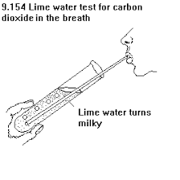****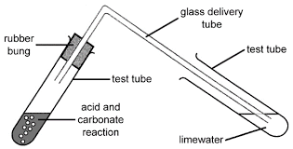****

****Reaction Rate Investigation - Concentration****

****Aim:** To investigate how the concentration of hydrochloric acid affects the rate at which it reacts with marble chips (calcium carbonate)**

****Hypothesis:****

**Increasing the concentration of hydrochloric acid increases the reaction rate with calcium carbonate.**

****Variables:****

**Independent: Concentration of hydrochloric acid**

**Dependent: Reaction rate between hydrochloric acid and calcium carbonate**

**Controlled:**

**temperature of reactants**

**surface area of calcium carbonate**

**test tubes**

**stop watch, person timing**

**agitation**

****Method:****

1. **Place one spatula of marble chips into a test tube.**
2. **Set up the equipment as shown below:**

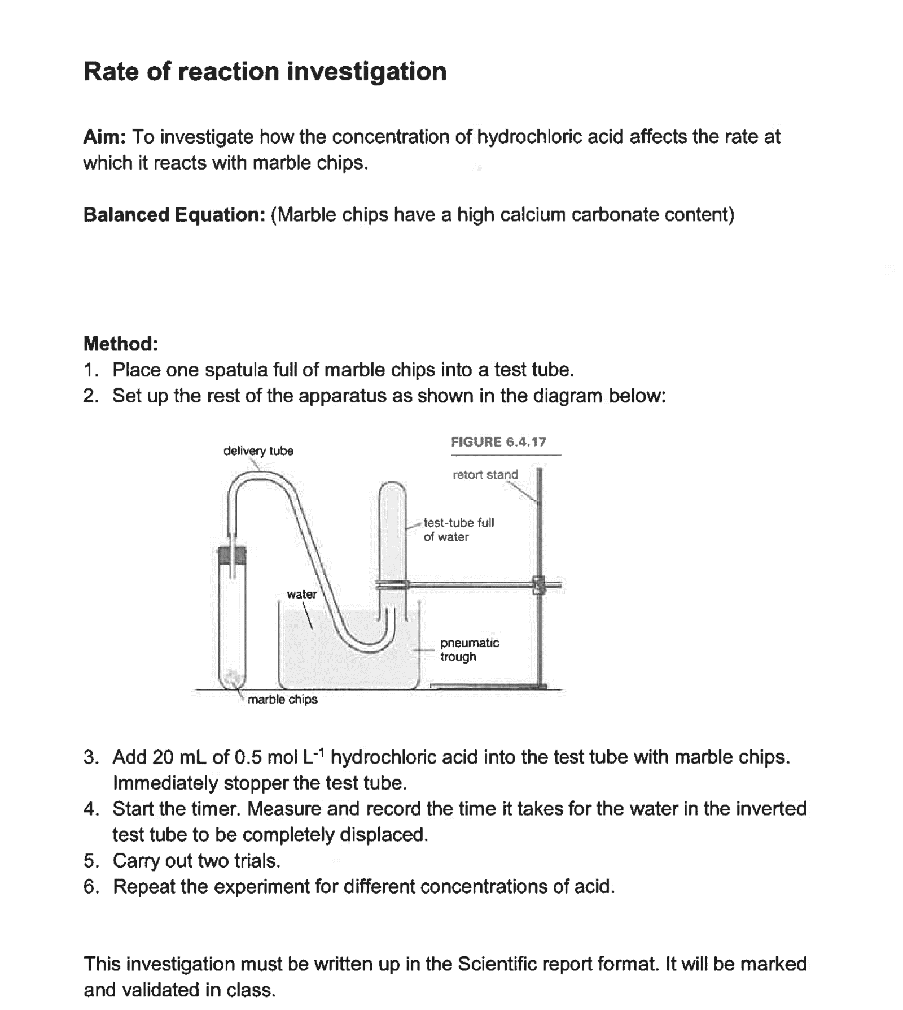

1. **Add 20 mL of 0.5 mol L-1 hydrochloric acid to the test tube with marble chips and immediately stopper the test tube.**
2. **Start the timer. Measure and record the time it takes for the water in the inverted test tube to be completely displaced.**
3. **Carry out two trials.**
4. **Repeat the experiment for different concentrations of acid.**

****Results table:****



|  |  |  |  |
| --- | --- | --- | --- |
| **Concentration**  **(mol L-1)** | **Time (s)** | | |
| **Trial 1** | **Trial 2** | **Average** |
| **0.5** |  |  |  |
| **1.0** |  |  |  |
| **2.0** |  |  |  |

****Graph:****



Graph Title: ……………………………………………………………………………...



`



****Discussion:****



****What happened?****

**The higher the concentration of hydrochloric acid the shorter the time for the carbon dioxide to fill the test tube.**

****Explain why it happened?****

**Increasing the concentration, decreases the distance between the acid particles. This increases the rate of collisions between the acid and calcium carbonate particles which increases the reaction rate.**

****Evaluation:****

****Reliability:****

**Results are reliable. Two trials were conducted that gave similar results and an average was calculated.**

****Accuracy:****

**Results are accurate. A stopwatch was used to measure time.**

****Validity:****

**The surface area of the calcium carbonate chips was not kept the same for each trial and there was a time delay between when the reaction started and the stopper was put into the test tube. This reduced the validity of the results.**

****Conclusion:****

**Increasing the concentration of hydrochloric acid increases the reaction rate with calcium carbonate. This supports the hypothesis.**

****Reaction Rate Investigation - Temperature****

****Aim:** To investigate how the temperature of hydrochloric acid affects the rate at which it reacts with marble chips (calcium carbonate)**

****Hypothesis:****

**Increasing the temperature of hydrochloric acid increases the reaction rate with calcium carbonate.**

****Variables:****

**Independent: Temperature of hydrochloric acid**

**Dependent: Reaction rate between hydrochloric acid and calcium carbonate**

**Controlled:**

**temperature of reactants**

**surface area of calcium carbonate**

**test tubes**

**stop watch, person timing**

**agitation**

****Method:****

1. **Place one spatula of marble chips into a test tube.**
2. **Set up the equipment as shown below:**



1. **Pour 20 mL of hydrochloric acid into a test tube and place in a water bath to change its temperature. Measure and record the temperature.**
2. **Add the acid the test tube with marble chips and immediately stopper the test tube.**
3. **Start the timer. Measure and record the time it takes for the water in the inverted test tube to be completely displaced.**
4. **Carry out two trials.**
5. **Repeat the experiment for the acid at different temperatures.**

****Results table:****

|  |  |  |  |
| --- | --- | --- | --- |
| **Temperature (°C)** | **Time (s)** | | |
| **Trial 1** | **Trial 2** | **Average** |
|  |  |  |  |
|  |  |  |  |
|  |  |  |  |

****Graph:****

Graph Title: ……………………………………………………………………………...





****Discussion:****

****What happened?****

**The higher the temperature of hydrochloric acid the shorter the time for the carbon dioxide to fill the test tube.**

****Explain why it happened?****

Increasing temperature will increase the proportion of collisions that have sufficient kinetic energy to meet the activation energy which increases the rate of successful collisions and so increases the reaction rate. Also, by increasing the kinetic energy of the particles, the particles move faster and so the rate of collisions increases which also increases the reaction rate.

****Evaluation:****

****Reliability:****

**Results are reliable. Two trials were conducted that gave similar results and an average was calculated.**

****Accuracy:****

**Results are accurate. A stopwatch that measured to one hundredth of a second was used to measure time.**

****Validity:****

**The surface area of the calcium carbonate chips was not kept the same for each trial and there was a time delay between when the reaction started and the stopper was put into the test tube. This reduced the validity of the results.**

****Conclusion:****

**Increasing the temperature of hydrochloric acid increases the reaction rate with calcium carbonate. This supports the hypothesis.**

****Reaction Rate Investigation – Surface Area****

****Aim:** To investigate how the surface area of the marble chips affects the rate at which it reacts with hydrochloric acid.**

****Hypothesis:****

**Increasing the temperature of hydrochloric acid increases the reaction rate with calcium carbonate.**

****Variables:****

**Independent: Surface area of the calcium carbonate chips**

**Dependent: Reaction rate between hydrochloric acid and calcium carbonate**

**Controlled:**

**temperature of reactants**

**concentration of HCl**

**test tubes**

**stop watch, person timing**

**agitation**

****Method:****

1. **Place one spatula of marble chips into a test tube.**
2. **Set up the equipment as shown below:**



1. **Add 20 mL of 1.0 mol L-1 hydrochloric acid to the test tube with marble chips and immediately stopper the test tube.**
2. **Start the timer. Measure and record the time it takes for the water in the inverted test tube to be completely displaced.**
3. **Carry out two trials.**
4. **Use a mortar and pestle to grind one spatula of marble chips into smaller pieces (this increases the surface area). Repeat the experiment using marble chips of different size pieces.**

****Results table:****

|  |  |  |  |
| --- | --- | --- | --- |
| **Surface area** | **Time (s)** | | |
| **Trial 1** | **Trial 2** | **Average** |
| **small (large pieces)** |  |  |  |
| **medium** |  |  |  |
| **Large (small pieces)** |  |  |  |

****Graph:****

Graph Title: ……………………………………………………………………………...







****Discussion:****

****What happened?****

**The greater the surface area of the calcium carbonate, the shorter the time for the carbon dioxide to fill the test tube.**

****Explain why it happened?****

Increasing the surface area of the calcium carbonate (by grinding it into smaller pieces) exposes more reactant particles to each other at the same time which increases the rate of collisions which increases the reaction rate.

****Evaluation:****

****Reliability:****

**Results are reliable. Two trials were conducted that gave similar results and an average was calculated.**

****Accuracy:****

**Results are accurate. A stopwatch that measured to one hundredth of a second was used to measure time.**

****Validity:****

**The surface area of the calcium carbonate chips was not kept the same for each trial and there was a time delay between when the reaction started and the stopper was put into the test tube. This reduced the validity of the results.**

****Conclusion:****

**Increasing the surface area calcium carbonate increases the reaction rate with hydrochloric acid. This supports the hypothesis.**

****Hydrogen****



|  |  |  |  |
| --- | --- | --- | --- |
|  |  | |  |
| **0.000055% of the atmosphere** | **Properties**  **odourless, tasteless, colourless, highly flammable/ combustible** |
| **Uses**  **rocket fuel**  **welding**  **production of hydrochloric**  **production of fertilisers** | Molar mass  2.016 g mol-1 |
| **Interesting facts**  **The only element that can exist without neutrons Because it is so light it was used in the Hindenburg, however, it is too dangerous.** | Hydrogen Gas (H2) - Structure, Properties and Uses |
|  | |

****Making hydrogen in the laboratory****

**Hydrogen can be made by reacting hydrochloric acid with magnesium.**

****Type of reaction****

**This reaction is known as an **acid-metal reaction**.**

****Word equation:****

**hydrochloric acid + magnesium → magnesium chloride + hydrogen**

****Balanced equation:****

**2HCl + Mg → MgCl2 + H2**

****Outline three ways that the rate of producing hydrogen in the laboratory could be increased.****

1. **Use more concentrated hydrochloric acid (increase concentration of HCl)**
2. **Heat up the hydrochloric acid (increase temperature of HCl)**
3. **Break up the magnesium strip into smaller pieces (increase surface area of Mg)**

****Test for hydrogen- pop test****

1. **Light a match.**
2. **Remove the gas jar lid and place the lit match in the mouth of the gas jar.**
3. **If it makes a “pop” then the gas in the jar is hydrogen.**

****Oxygen****

|  |  |  |  |
| --- | --- | --- | --- |
|  |  | |  |
| **20% of the atmosphere** | **Properties**  **odourless, tasteless, colourless, supports combustion** |
| **Uses** | Molar mass  32.00 g mol-1 |
| **Interesting facts** |  |
|  | |

****Making oxygen in the laboratory****

**Oxygen can be made through the decomposition of hydrogen peroxide. Hydrogen peroxide decomposes very slowly to produce water and oxygen gas. By adding a **catalyst**, manganese IV oxide (MnO2), it will decompose rapidly.**

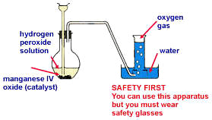

****Type of reaction****

**This reaction is known as a **decomposition reaction**.**

****Word equation:****

**hydrogen peroxide → oxygen + water**

****Balanced equation:****

**2H2O2 → O2 + 2H2O**

****Test for oxygen- glowing splint test****

1. **Light a wooden splint and gently blow it out so that it still glows.**
2. **Remove the gas jar lid and place the splint in the mouth of the jar.**



1. **If the glowing splint reignites then the gas in the jar is oxygen**



****Introduction to chemistry calculations – Extension****

****n – mole (mol)****

* In real chemical reactions there are millions of billions of billions of atoms involved – not practical to talk about the actual number of atoms
* Chemists use the word ‘mole’ to refer to a certain number of particles, similar to the word ‘dozen’
* Dozen = 12
* Mole = 6.022 x 1023 = 602 200 000 000 000 000 000 000
* This number is chosen so that the 1 mole of hydrogen atoms weighs 1 g
* Mole is commonly abbreviated to mol

****M – molar mass (g mol-1)****

* The mass numbers on the periodic table are also the molar mass of those elements in   
  g mol-1 – the mass of 1 mole of that element
* These numbers are rarely whole numbers because they are the averages of the natural isotopes for those elements (and another reason that is discussed in ATAR Physics)
* The molar masses on the periodic table apply to the individual elements, but can also be used to find the molar mass of compounds and elemental molecules

****Molar mass of compounds****

* The molar mass of a compound is the sum of the molar masses of each atom in the formula (values on periodic table)
* E.g., M(CO2)=M(C)+M(O)+M(O)=12.01+16.00+16.00= 44.01 g mol-1
* M(Ca3(PO4)2)=3xM(Ca)+2xM(P)+8xM(O)=3x40.08+2x30.97+8x16= 310.18 g mol-1

****Examples****

1. Determine the molar mass of NaCl

M(NaCl)=22.99+35.45=58.44 g mol-1

1. Determine the molar mass of Al2S3

M(Al2S3)=(2x26.98)+(3x32.07)=150.17 g mol-1

1. Determine the molar mass of (NH4)2CO3

M((NH4)2CO3)=(2x14.01)+ (8x1.008)+12.01+(3x16.00)=96.094 g mol-1

****Moles equation****

* Main equation used for basic chemistry calculations:

****Examples****

1. Determine the number of moles of CuSO4 in 120 g

M = 63.55+32.06+(4x16.00) = 159.61 g mol-1

n=120/159.61 = 0.752 mol

1. How many moles is 1.54 kg of Fe2(CO3)3?

M = (2x55.85) + (3x12.01)+ (9x16)= 291.73 g mol-1

n(Fe2(CO3)3)=1540/ 291.723 = 5.279 mol

1. Calculate the number of moles of ammonium phosphate in 1249 g (NH4)3PO4

M = (3x14.01)+(12x1.008)+(30.97)+(4x16.00) = 149.096 g mol-1

n((NH4)3PO4)=1249/ 149.0896 =8.377 mol

****Rearranged equation****

* Can be rearranged to solve for mass – not given to you in assessments

****Examples****

1. Find the mass of 3.47 moles of LiOH

M = 6.94+16.00+1.008= 23.948 g mol-1

m(LiOH)= 3.47x 23.948= 83.1 g

1. Determine the mass of 1.24x103 moles of CaSO4

M = 40.08+32.06+(4x16.00)= 136.14 g mol-1

m = 1240x(136.14) = 168813.6 g

1. Calculate the mass of 0.495 moles of aluminium carbonate

M = (2x26.98) + (3x12.01) + (9x16.00) = 233.99 g mol-1

m(Al2(CO3)3)=0.495 x 233.99 =115.825 g

**Precipitation reactions**

Ionic substances that dissolve in water are referred to as soluble. In water the ions separate and are no longer chemically bound together, this is referred to as a solution.

Ionic substances that do not dissolve are referred to as insoluble. Even in water the ions remain bound together as a compound.

If two solutions are mixed sometimes an insoluble compound can form from the positive ions from one substance with the negative ions from the other. In this case, a solid forms out of the solution. The solid forms as tiny crystals dispersed in the water, this happens instantly and turns the mixture opaque. This is known as a precipitation reaction. Some ions remain dissolved in the water as a solution.

**Subscripts in equations**

In the equations above we have included subscripts in brackets after each species. These show its state; solid, liquid, gas or aqueous (dissolved in water).

|  |  |
| --- | --- |
| (s) | solid |
| (l) | liquid |
| (g) | gas |
| (aq) | aqueous (dissolved in water) |

**Solubility table**

In order to predict the result of these reactions we must understand which ionic substance are soluble and which are insoluble. This can be determined by referring to the solubility tables below, which will be given to you in assessments.

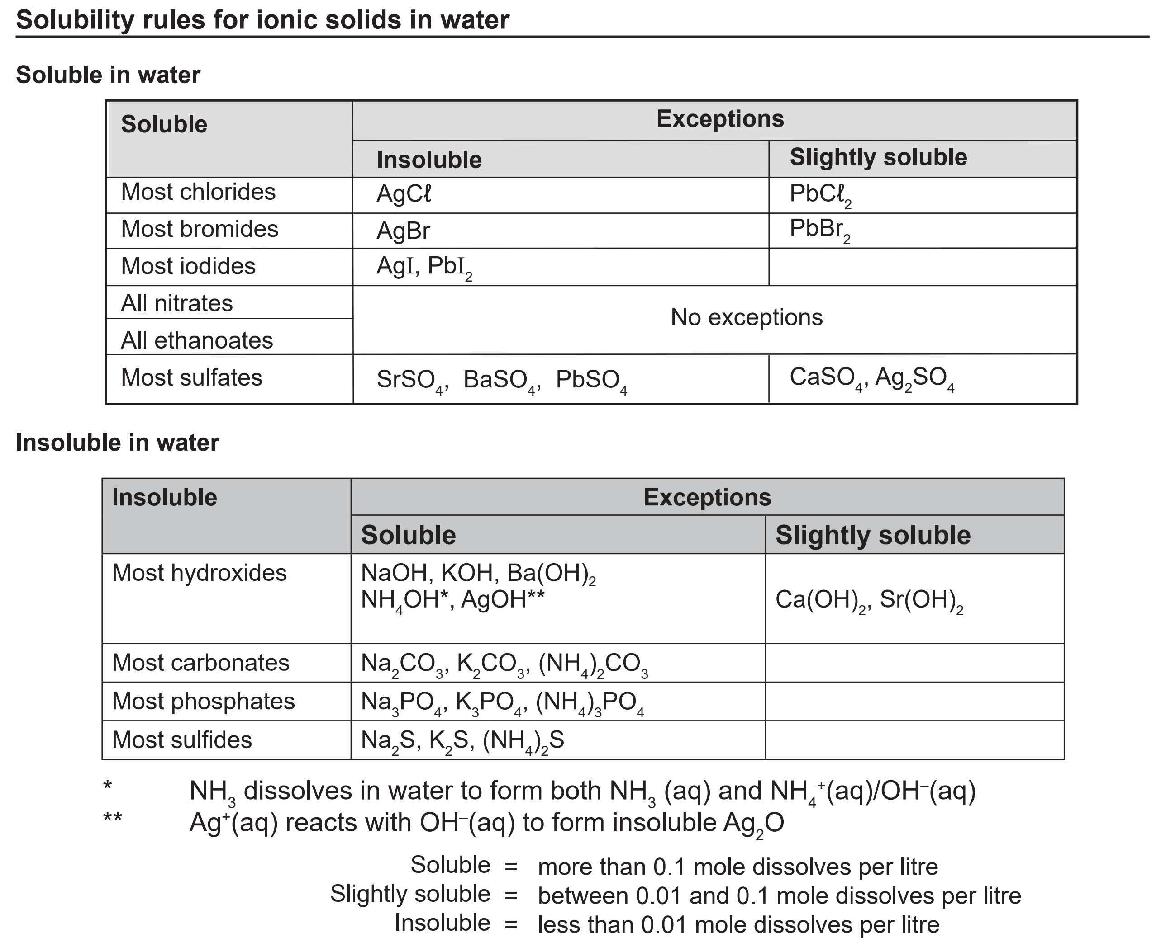

The tables are organized by negative ion, with exceptions listed to the right. Treat anything referred to as slightly soluble as being insoluble.

**Examples**

1. For each of the following substances, determine whether they are soluble or insoluble:
   1. sodium nitrate - soluble
   2. potassium carbonate - soluble
   3. barium sulfate - insoluble
   4. calcium hydroxide - insoluble
   5. lithium chloride - soluble
   6. copper (II) sulfide - insoluble
   7. copper (II) sulfate - soluble
   8. ammonium phosphate - soluble
   9. lead (II) bromide - insoluble

**Predicting the products of a possible precipitation reaction**

When two ionic solutions are mixed, we must check if anything insoluble can form from the ions. The simplest way of doing this is a partner swap.

1. Exchange the negative ions of the two ionic compounds e.g.:

Sodium chloride solution is combined with silver nitrate solution.

sodium chloride + silver nitrate → sodium nitrate + silver chloride

NaCl + AgNO3 → NaNO3 + AgCl

1. Then check the solubility of each product (the reactants will always be soluble)

NaCl + AgNO3 → NaNO3 + AgCl

soluble soluble soluble insoluble

1. Add subscripts to show the solubility

NaCl(aq) + AgNO3(aq) → NaNO3(aq) + AgCl(s)

The equation now shows that when solutions of sodium chloride and silver nitrate are mixed, a solid precipitate of silver chloride will form leaving sodium nitrate in solution.

**Both soluble**

If both products are soluble there is no reaction e.g.:

NaCl(aq) + KNO3(aq) → NaNO3(aq) + KCl(aq)

Everything is still dissolved in the water, so instead we write:

NaCl(aq) + KNO3(aq) → no reaction

**Both insoluble**

In certain pairings it is possible for there to be two precipitates e.g.:

Ba(OH)2(aq) + MgSO4(aq) → BaSO4(s) + Mg(OH)2(s)

Make sure you check both.

**Examples**

Write a balanced chemical equation for the following reactions:

1. Solutions of potassium iodide and silver nitrate are mixed

KI(aq) + AgNO3(aq) → KNO3(aq) + AgI(s)

1. solutions of ammonium phosphate and sodium sulfate are mixed

(NH4)3PO­4(aq) + Na2SO4(aq) → no reaction

1. solutions of aluminium chloride and sodium hydroxide are mixed

AlCl3(aq) + 3NaOH(aq) → Al(OH)3(s) + 3NaCl(aq)

1. solutions of lithium sulfate and calcium nitrate are mixed

Li2SO­4(aq) + Ca(NO3)2(aq) → CaSO4(s) + 2LiNO3(aq)

1. solutions of iron (III) sulfate and barium hydroxide are mixed

Fe2(SO4)3(aq) + 3Ba(OH)2(aq) → 3BaSO4(s) + 2Fe(OH)3(aq)

1. solution of ammonium sulfate and barium chloride are mixed

(NH4)2SO4(aq) + BaCl2(aq) → 2NH4Cl(aq) + BaSO4(s)

1. solutions of ammonium carbonate and magnesium sulfate are mixed

(NH4)2CO3(aq) + MgSO4(aq) → MgCO3(s) + (NH4)2SO4(aq)

1. solutions of barium nitrate and copper (II) sulfate are mixed

Ba(NO3)2(aq) + CuSO4(aq) → Cu(NO3)2(aq) + BaSO4(s)

1. solutions of sodium iodide and lead (II) acetate are mixed

2NaI(aq) + Pb(CH3COO)2(aq) → PbI2(s) + 2NaCH3COO(aq)

1. solutions of barium nitrate and potassium sulfide are mixed

Ba(NO3)2(aq) + K2S(aq) → 2KNO3(aq) + BaS(s)

**Ionic Equations**

Soluble ionic substances in solution do not exist as ionic compounds, the ions separate and move independently. This can be better shown in equations by separating the ions.

E.g.:

NaCl(aq) + AgNO3(aq) → NaNO3(aq) + AgCl(s)

Na+(aq) + Cl-(aq) + Ag+(aq) + NO3-(aq) → Na+(aq) + NO3-(aq) + AgCl(s)

Once this is done, it can be seen that some ions did not change in the reaction, they were present at the start of the reaction, and are present at the end. These are known as spectator ions and can be removed from the equation:

Cl-(aq) + Ag+(aq) → AgCl(s)

This is then referred to as an ionic equation and is the clearest way to represent a precipitation reaction.

**Examples**

Write balanced ionic equations for the reactions below:

1. solutions of iron (II) sulfate and barium hydroxide are mixed

Fe2+(aq) + SO42-(aq) + Ba2+(aq) + 2OH-(aq) → Fe(OH)2(s) + BaSO4(s)

1. solutions of calcium chloride and potassium phosphate are mixed

3Ca2+(aq) + 2PO43-(aq) → Ca3(PO4)3(s)

1. solutions of calcium nitrate and sodium chloride are mixed

no reaction = no observable change

1. solution of potassium chloride and silver nitrate are mixed

Ag+(aq) + Cl-(aq) → AgCl(s)

1. solutions of sodium sulfide and nickel (II) sulfate are mixed

Ni2+(aq) + S2-(aq) → NiS(s)

1. solutions of ammonium sulfate and barium chloride are mixed

Ba2+(aq) + SO42-(aq) →BaSO4(s)

1. solutions of sodium sulfide and zinc sulfate are mixed

Zn2+(aq) + S2-(aq) → ZnS(s)

1. solutions of aluminium nitrate and sodium phosphate are mixed

Al3+(aq) + PO43-(aq) → AlPO4(s)

1. solutions of ammonium carbonate and magnesium sulfate are mixed

Mg2+(aq) + CO32-(aq) → MgCO3(s)

1. solutions of sodium sulfate and potassium sulfide are mixed

no reaction

1. solutions of lead (II) nitrate and lithium iodide are mixed

Pb2+(aq) + 2I-(aq) → PbI2(s)

**Revision**

1. Give three examples of a metal, a non-metal, a semi-metal (metalloid) and a noble gas.

Metal: lithium, sodium, magnesium, iron, copper, gold, etc.

Non-metal: carbon, nitrogen, oxygen, hydrogen, etc.

Semi-metal: silicon, germanium, arsenic, antimony, etc.

Noble gas: helium, neon, argon, krypton, etc.

1. Using examples, define the terms below:
   1. atomic number: the number of protons in an element’s nucleus, e.g., 1 for hydrogen, 2 for helium
   2. mass number: the number of protons+neutrons in an element’s nucleus, e.g. 35 for Cl-35
   3. isotope: atoms of an element with the same number of protons but varying numbers of neutrons, e.g., C-12 has 6 protons, 6 neutrons, while C-14 has 6 protons, 8 neutrons
   4. ion: an atom that has lost or gained electrons giving it a net charge, e.g., a chloride ion has gained one electron giving it a negative 1 charge
2. Copy and fill out the following table.

|  |  |  |  |  |  |  |
| --- | --- | --- | --- | --- | --- | --- |
| Element | Charge | Mass No. | Atomic No. | No. Protons | No. Neutrons | No. Electrons |
|  | neutral | 108 | 47 | 47 | 61 | 47 |
|  | 2+ | 24 | 12 | 12 | 12 | 10 |
| 168O | neutral | 16 | 8 | 8 | 8 | 8 |
| S2- | 2- | 32 | 16 | 16 | 16 | 18 |
| 2713Al3+ | 3+ | 27 | 13 | 13 | 14 | 10 |

1. Write the formula for the following compounds:
   1. sodium acetate NaCH3COO
   2. sulphur dioxide SO2
   3. magnesium nitrate Mg(NO3)2
   4. aluminium sulphide Al2S3
   5. ammonium bromide NH4Br
   6. lead (II) hydrogensulfate Pb(HSO4)2
   7. triphosphorus tetroxide P3O4
   8. tin (II) nitride Sn3N2
   9. chromium (III) oxide Cr2O3
   10. manganese (II) sulfate MnSO4
   11. lithium hydrogencarbonate LiHCO3
   12. dinitrogen heptabromide N2Br7
2. Name the following compounds:
   1. CrCl3 chromium (III) chloride
   2. AlPO4 aluminium phosphate
   3. AgNO3 silver nitrate
   4. Fe(OH)3 iron (III) hydroxide
   5. S3O8 trisulfur octoxide
   6. Ca(HCO3)2 calcium hydrogencarbonate
   7. P­2F6 diphosphorous hexafluoride
   8. Pb(NO3)2. lead (II) nitrate
3. Balance the following equations:

2PbO + C → CO2 + 2Pb

2Al + 3Br2 → 2AlBr3

H2CO3 + 2KOH → 2H2O + K2CO3

2C2H6 + 7O2 → 4CO2 + 6H2O

6HC*l* + Fe2(CO3)3 → 3H2O + 3CO2 + 2FeCl3

1. Write balanced chemical equations for the following reactions:
2. The decomposition of copper (II) carbonate forming copper (II) oxide, and carbon dioxide.

**CuCO3**(s)→ **CuO**(s) **+ CO2**(g)

1. The decomposition of strontium hydrogencarbonate forming strontium oxide, water and carbon dioxide.

**Sr(HCO3)2(s)** → **SrO(s) + 2CO2(g) + H2O(l)**

1. Zinc is added to chlorine gas producing zinc chloride.

**Zn(s) + Cl2(g)** → **ZnCl2(s)**

1. The decomposition of potassium hydrogencarbonate producing potassium oxide, water and carbon dioxide.

**2KHCO3(aq)** → **K2O(aq + H2O(l) + 2CO2(g)**

1. Write the electron configurations for the following substances.
2. Ca (2,8,8,2)
3. Ar (2,8,8)
4. B (2,3)
5. S2- (2,8,8)
6. K+ (2,8,8)

**Vi** P3- (2,8,8)

1. Draw electron dot diagrams for the following:



1. A*l*



1. N



1. Mg2+



1. C*l*‒



1. O2-



1. He



1. a) Name the element in period 3 and group 16. Sulfur

b) Using examples, describe the relationship between the number of energy shells (levels) and valence electrons an atom has and its position on the periodic table.

The number of **valence electrons** that an atom of an element has determines the **group**

(column) it is in.

The number of **energy levels** that an atom of an element has determines the **period** (row) it is in.

Eg

Calcium has two valence electrons and is in group 2, it has four energy levels and is in group 4.

1. Complete the table below:

|  |  |  |  |
| --- | --- | --- | --- |
| **GAS** | **Drawing** | **Test** | **% in atmosphere** |
| Carbon dioxide (CO2) |  | Limewater test | 0.04 % |
| Hydrogen (H­2) |  | Pop test | 0.000055 % |
| Oxygen (O2) |  | Glowing splint test | 20% |

1. Identify the type of reaction that is used to produce the following gases in the laboratory. You can choose from: acid-metal, decomposition or acid-carbonate.

* 1. **Making CO2**: CaCO3 + 2HCl → CaCO3 + H2O + CO2

Reaction type: acid- carbonate

* 1. **Making H2**: Mg + 2HCl → MgCl2 + H2

Reaction type: acid- metal

* 1. **Making O2**: 2H2O2 → 2H2O + O2

Reaction type: decomposition

1. In the following reaction; 2A*l*(s) + 3H2SO4(aq) → A*l­*2(SO4)3(aq) + 3H2(g), explain three ways to speed this reaction up (i.e., describe how the reaction rate increases rather than just listing how it could be sped up)
2. Heat up H2SO4 acid (increase temperature)

Increasing temperature increases the kinetic energy of the particles. This will mean a greater proportion of particles will have sufficient energy for a successful collision to react and secondly as the particles are moving faster the rate of collisions will also increase, increasing the chance of reaction.

1. Increase the concentration of the H2SO4 acid.

This increases the number of particles per volume which increases the rate of collisions for reaction.

1. Cut aluminium up into smaller pieces (increase surface area)

Increasing the surface area of the aluminium will increase the number of reacting particles exposed to each other and colliding at one time for reaction to occur.

1. Add a catalyst.

Adding a catalyst provides an alternative reaction pathway which requires less energy for particles to react so more particles have sufficient energy for reaction.

1. Agitate (stir/ swirl) the reaction.

This increases the number of reactant particles exposed to each other so there are a greater number of collisions for reaction to occur.

**Extension revision**

1. On the periodic table, the relative atomic mass of calcium is given as 40.08. Explain why it is not a whole number.

It is not a whole number because it is the average of different isotopes of calcium with different masses.

1. Calculate the molar mass of the following:
   1. sulphur trioxide 80.06 or 80.07 g mol-1
   2. lithium nitrite 52.95 g mol-1
   3. strontium iodide 341.42 g mol-1
   4. iron (III) acetate (ethanoate) 232.982 g mol-1
   5. dinitrogen tetroxide. 92.02 g mol-1
2. Calculate the number of moles of the following:
3. CO2 in 123.9 g of CO2 2.82 mol
4. Na2SO­3 in 54.9 g of Na2SO­3 0.436 mol
5. O atoms in 986.5g of Fe(HSO4)3 2.84 mols Fe(HSO4)3 so 34.1 mols of O atoms
6. Calculate the mass of the following:
   1. 6.53×104 mol of Sr3N2 18994464 g
   2. 2.67×10-2 mol of Pb(OH)2 6.44 g
7. Write ionic equations for following reactions:
   1. Barium hydroxide solution reacts with potassium sulphate solution.

Ba2+(aq) + SO42-(aq) → BaSO4(s)

* 1. Lead nitrate solution reacts with potassium iodide solution.

Pb2+(aq) + 2I-(aq) → PbI2(s)

* 1. Ammonium bromide solution is added to sodium sulphide solution.

No observable change